Thank you for purchasing the TAPR WSPR Transmitter. Below are the steps to get it up and running. This page is intended as a starting point. The remainder of the instructions can be downloaded from the TAPR website -

TAPR WSPR

The download links are located at the bottom of the page.

In addition to the WSPR kit, you'll also need the following to have a complete WSPR transmitter -

- Raspberry Pi 2, 3 or 4 (Pi). We recommend getting a Pi 3 or 4. They have built in WiFi and faster processor (the Pi 2 does not) … One source is Adafruit (Adafruit Raspberry Pi). We have no connection with Adafruit.

- Soldering Iron, Solder, Wire Cutters

- 2.5 amp power supply w/micro USB connector. This plugs into the micro USB connector of the Pi. Adafruit is one source (https://www.adafruit.com/product/1995). A word of caution: don't cheap out on the power supply. A weak power supply will cause intermittent problems that are very hard to diagnose. Make sure the power supply will deliver at least 2 amps, and preferably more. This is cheap insurance.

- Ethernet cable. You need to connect the Pi to your network over Ethernet (wired connection) for initial setup. You can switch to WiFi after that.

- WiFi USB dongle. You only need this if you're using an Pi 2 and you want to use WiFi. Here is a WiFi dongle example: Adafruit WiFi USB Dongle.

- SD card (4 GB min, grade 10)

- SD card reader (micro SD card to USB)

- Antenna (mate to BNC connector on VW)

- Contact us at contact@tapr.org for help or troubleshooting.

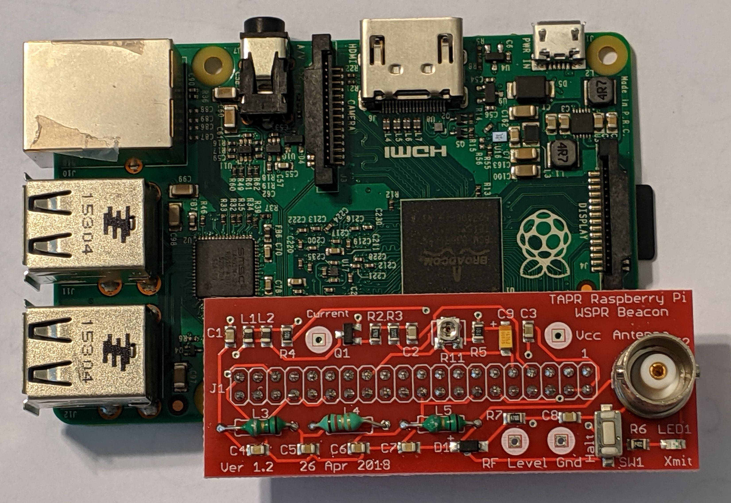

We intentionally did not install the low pass filter (LPF) components so that we can use a common board for multiple bands and provide specific LPF components for each band. You should have received a packet of components (4 capacitors and 3 inductors) along with the board for your kit. The inductors should be installed into spaces marked L3, L4 and L5 on the board (the inductors are all the same value, so it doesn’t matter which inductor goes where). The capacitor values are shown in Table 1 and go into spaces marked C4, C5, C6 and C7 (See Table below).
Band | C4, C7 | C5, C6 | L3, L4, L5
15m/17m | 151 (150 pF) | 271 (270 pF) | yel-pur-silver-silver (470 nH)
10m,12m | 121 (120 pF) | 221 (220 pF) | ora-wht-silver-silver (390 nH)
Table 1: Low Pass Filter Component Values

Happy WSPRing!
73, TAPR

